Comparisons between tools are always tricky. Firstly, many things like usability come down to personal opinion. Secondly, putting together benchmarks meaningful to a broad audience takes a lot of time to do properly and are frequently out of date within 3-6 months.

If you have the time, we encourage you to try out the different tools and judge their merits for yourself. Failing that, we suggest you try Bazaar first. As explained below, you can always switch to Mercurial or Git afterwards if Bazaar doesn’t meet your needs.

If you’ve ever collaborated with other people on a project, you know the frustration of constantly swapping files. Some do it by email, some through file upload services and some by other methods. It’s a pain in the neck, and every designer and developer knows it.” **Revision control system**” is *an excellent way to combat the problem of sharing files between workers*.

Most web-developers have probably worked with some sort of revision control system, but designers may find it a foreign concept. The most obvious benefit of using revision control is the ability to have an unlimited number of people working on the same code base, without having to constantly send files back and forth.

But designers and developers can both benefit from using revision control systems to keep copies of their files and designs. You can instantly browse previous “commits” to your repository and revert to earlier versions if something happens.

there were **some of the top open-source version control systems** and tools that make setting up a version control system easy

top 3 are:-

1-Git (written in a collection of Perl, C, and various shell scripts, designed by [Linus Torvalds](http://en.wikipedia.org/wiki/Linus_Torvalds) based on the needs of the [Linux kernel](http://en.wikipedia.org/wiki/Linux_kernel) project; decentralized, and aims to be fast, flexible, and robust)

2-Mercurial (written in [Python](http://en.wikipedia.org/wiki/Python_%28programming_language%29) as an Open Source replacement to [BitKeeper](http://en.wikipedia.org/wiki/BitKeeper); decentralized and aims to be fast, lightweight, portable, and easy to use)

3- Bazaar (written in [Python](http://en.wikipedia.org/wiki/Python_%28programming_language%29), originally by Martin Pool and sponsored by [Canonical](http://en.wikipedia.org/wiki/Canonical_Ltd.); decentralised, and aims to be fast and easy to use; can losslessly import Arch archives)

ggi.PNG

- is a [free and open source](http://git-scm.com/about/free-and-open-source) distributed version control system designed to handle everything from small to very large projects with speed and efficiency.

-is the new fast-rising star of version control systems. Initially developed by Linux kernel creator Linus Torvalds, Git has recently taken the Web development community by storm. Git offers a much different type of version control in that it’s a **distributed version control system**. With a distributed version control system, there isn’t one centralized code base to pull the code from. Different branches hold different parts of the code. Other version control systems, such as SVN and CVS, use centralized version control, meaning that only one master copy of the software is used.

- prides itself on being a fast and efficient system, and many major open-source projects use Git to power their repositories

mer.PNG

-is another **open-source distributed version control system**, like Git. Mercurial was designed for larger projects, most likely outside the scope of designers and independent Web developers. That doesn’t mean that small development teams can’t or shouldn’t use it. Mercurial is extremely fast, and the creators built the software with performance as the most important feature. The name “mercurial” is an adjective that means “Relating to or having characteristics (eloquence, swiftness, cleverness) attributed to the god Mercury.”

Aside from being very fast and scalable, Mercurial is a **much simpler** system than Git, which is why it appeals to some developers. There aren’t as many functions to learn, and the functions are similar to those in other CVS systems. It also comes equipped with a stand-alone Web interface and extensive documentation on understanding Mercurial if you have been using another system.



Bazaar is a version control system that helps you track project history over time and to collaborate easily with others. Whether you're a single developer, a co-located team or a community of developers scattered across the world, Bazaar scales and adapts to meet your needs. Part of the [GNU Project](http://www.gnu.org/), Bazaar is free software sponsored by [Canonical](http://canonical.com/).

The top reasons for switching to Bazaar are:

-- Version control for everyone (free)

-- Work offline (not necessary to be connected to a Network or LAN )

-- Any workflow

-- Cross platform support (Windows , Mac OS , Linux)

-- tracking and smart merging

-- High storage efficiency and speed

-- Any workspace model

-- Plays well with others

What is the best version Control System from three previous tools

(Git & Mercurial & Bazaar ) ……… !!   
  
--simple Graphical Comparison

# comp.PNGgit.PNG

mercurial.PNGbazar.PNG

Comparisons between tools are always tricky and the best depends on your needs

But there is an advantage of Git Revision Control System

It is

## Branching and Merging

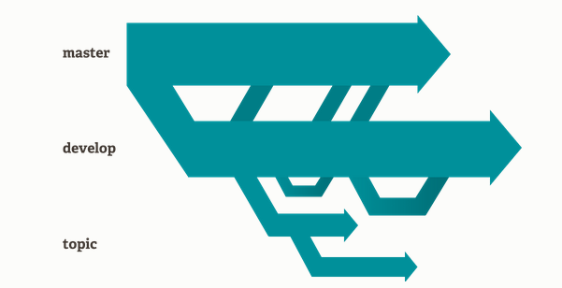

The Git feature that really makes it stand apart from nearly every other SCM out there is its branching model.

Git allows and encourages you to have multiple local branches that can be entirely independent of each other. The creation, merging, and deletion of those lines of development takes seconds.